主标题：handheld pda printer
副标题：HT600 6 inch handheld pda printer
Key parameters：
System / Performance: Android 13 / 8-core 2.0GHz / Up to 4GB+64GB
Printing function: 58mm thermal printing / 70mm/s high speed / support for label adhesive
Display screen 6.0" IPS (720P / 1080P) / Glove & Wet Touch
Scanning engine: Optional professional 2D hardware decoding (Honeywell N5703, etc.)
Battery capacity: Max 8000mAh / 18W fast charging / supports battery removal
Protection/Weight: IP68 (main unit) / 1.5m drop resistance / weight <350g
Recognition module: NFC, LF RFID (125K/134.2K)
handheld pda printer -1
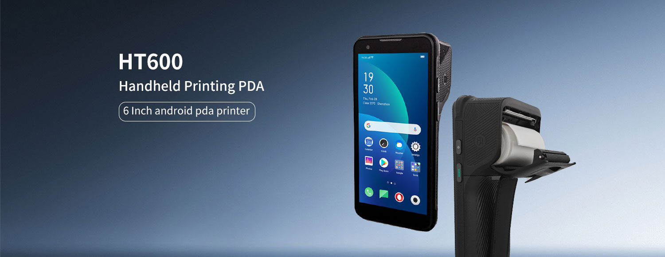
HT600 handheld pda printer is a high-performance barcode, QR code scanning, and thermal printing handheld terminal independently developed by LQYCIT. Android 13 operating system, equipped with a high-performance 8-core 2.0GHz clock speed processor, 6-inch high-definition large screen, and 16 million camera; Standard memory 3G+32G,Function options: barcode, QR code scanning NFC、 Thermal printing. IP68 protection level, strong industry adaptability, widely used in various application fields such as logistics, retail, warehousing, medical, power, one card, parking fees, government projects, etc., helping users quickly achieve information management and improve enterprise operation efficiency.

handheld pda printer -2
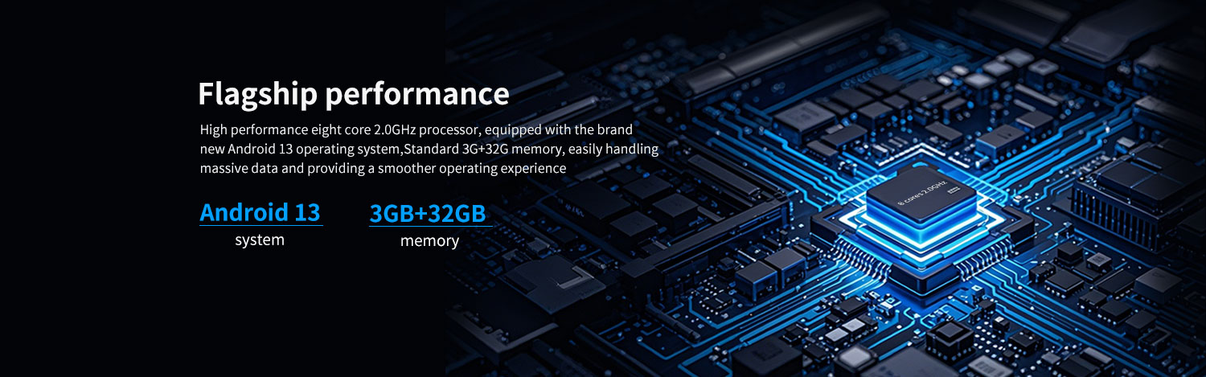
High performance CPU
The HT600 handheld pda printer adopts a high-performance eight core 2.2GHz CPU, which can provide lightning fast response speed when running applications and processing large amounts of inventory data. It is equipped with a brand new Android 13 operating system, providing a better work experience, improving application compatibility, and enhancing enterprise level data security protection.
handheld pda printer -3
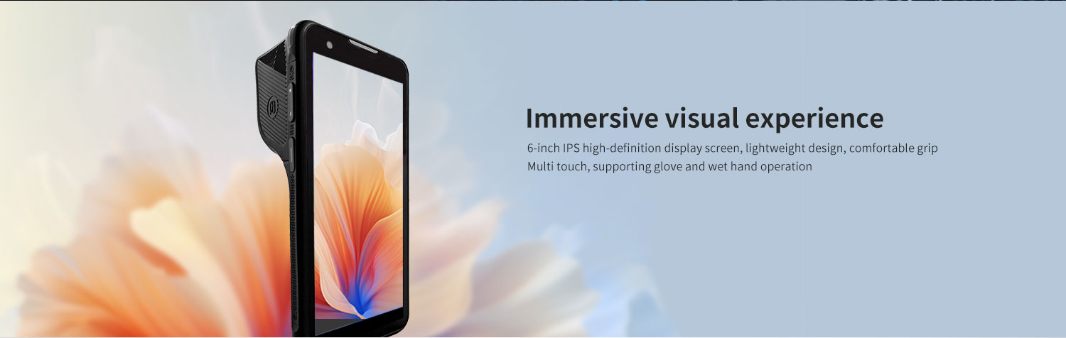
6-inch high-definition large screen
The 6-inch IPS display has a resolution of 1440 × 720P. The industrial grade high brightness screen provides good visibility even in outdoor sunlight. A larger screen provides a more interactive experience. The rear 16 megapixel camera has autofocus function, making it easy to capture high-quality live images.
handheld pda printer -4
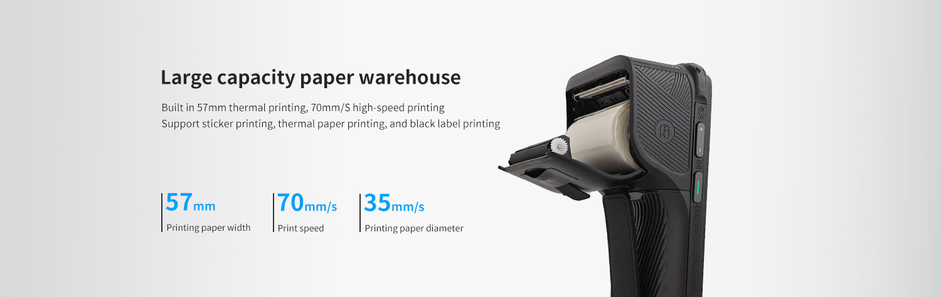

thermal printing
Printing paper width 57mm, diameter 35mm
Printing paper types: Supports sticker printing, thermal paper printing, and black label printing
handheld pda printer -5
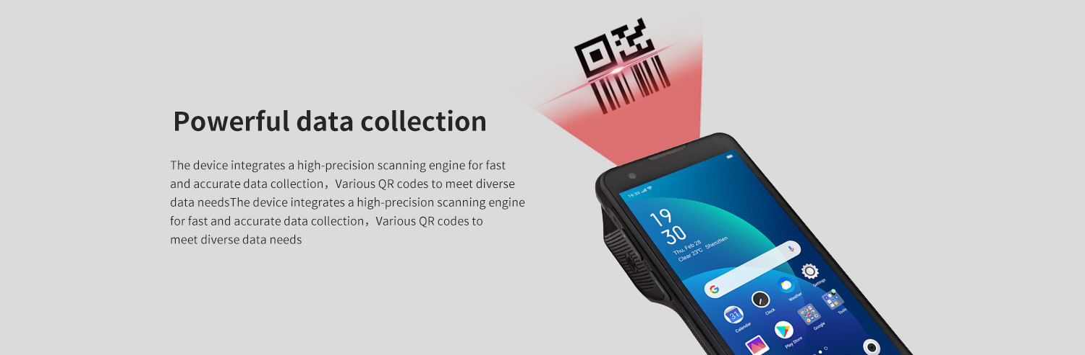
data collection
Barcode scanning: comes standard with professional barcodes and a QR code scanning engine. Whether it's stains, reflections, or long-distance barcodes, it can achieve precise and fast "scan and get".
handheld pda printer -6
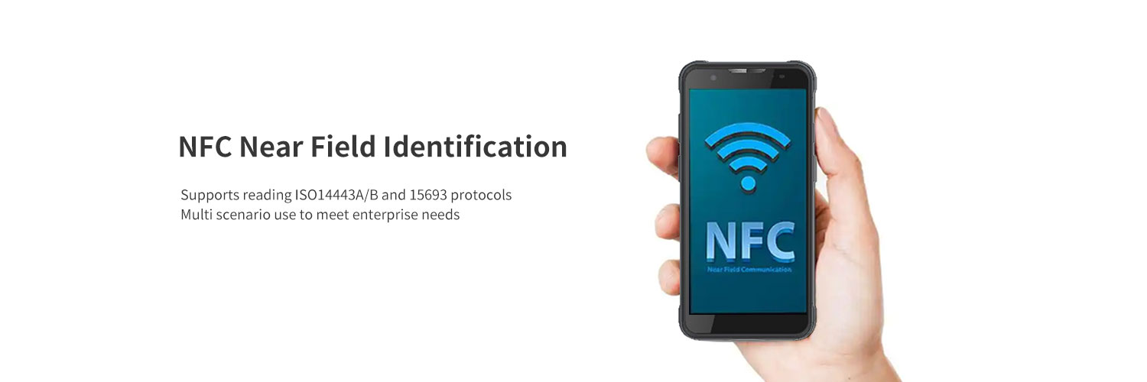
NFC function: Integrated NFC read-write module, operating frequency: 13.56MHz; Protocol standards: Supports ISO14443A/B and 15693 protocols; Perfectly supports near-field recognition applications such as employee cards, membership cards, device tags, and smart cards.

Ultra long battery life, online all day long
Equipped with a rechargeable polymer battery (standard 7.7V, 4000mAh), a large capacity detachable battery that supports fast charging technology and can replace the RTC battery without shutting down. Ensure that the device can still support full class operation under high-intensity use without frequent charging.
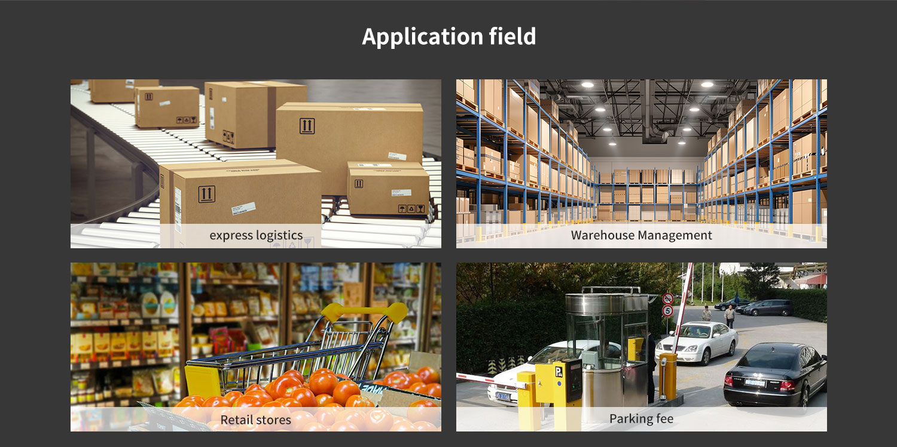
frequently asked questions
Q: Are you the original manufacturer?

A: Yes, we are the original manufacturer. We have our own brand LQYCIT. All of our products have complete patented ID/MD designs, hardware and software, molds, and assembly are all completed by our own team.

Q: Can you pre install our software?

A: Yes, we can pre install your software.

Q: What is the minimum order quantity?

A: We accept standard product orders starting from one unit. If necessary, we can even customize your logo. For OEM, our sales team will review the detailed requirements and confirm the minimum order quantity.

Q: Can we get free samples?

A: Sorry, we usually do not provide free samples. If the customer confirms the specifications and pricing, they can first order samples for testing and evaluation.

Q: How to place an order and make payment?

A: We accept wire transfers (bank transfers), Alibaba online payments, and Western Union remittances.

Q: What is the warranty period for your products?

A: We offer a 12-month warranty after shipment.

Q: How long is the delivery time?

A: The production delivery cycle is about 3-10 days, depending on the requirements. The delivery time through DHL/UPS/FedEx/TNT is approximately 3-5 working days. For some remote areas, the transportation time may be longer.

Q: How to fix equipment problems?

A: We will provide online technical support to solve problems. For hardware issues, we can ship parts or components for customers to install (if they have technicians), or we can ship them back to us for repairs.

